PE Funding

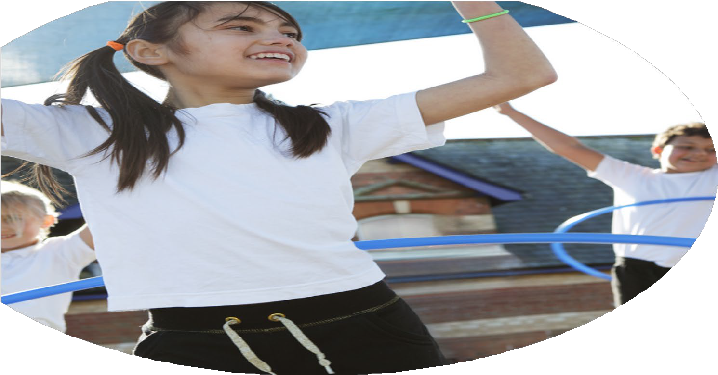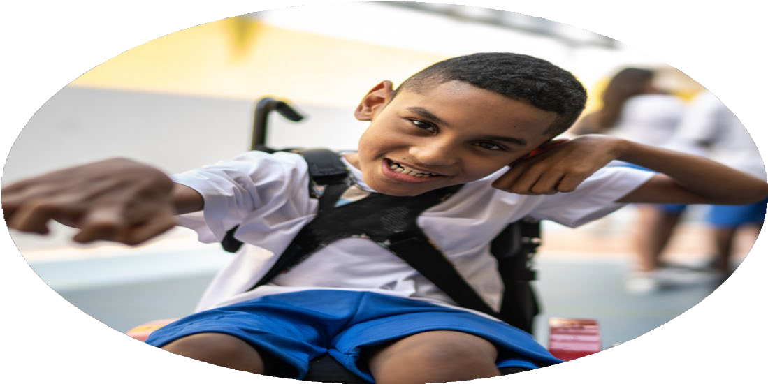

Evaluation Form

**Commissioned by**

**Created by**

Images courtesy of Youth Sport Trust

**PE Funding Evaluation Form**

 It is intended that this template should be used as preparation for the completion of the statutory digital reporting tool being introduced this academic year. You can upload data (including swimming) from this template onto this platform once it becomes accessible.

 Before you decide how you are going to use the funding for this academic year you should reflect and evaluate the impact of your use of the funding in 2023/24.

 All spending of the funding must conform with the terms outlined in the Conditions of Grant document.  The template is a working document that you can amend/update during the year.

 Based on your evaluation of last year’s funding you should decide what you intend to do this academic year, how you will do it, and what impact you expect it to have.

It is important that the funding is used effectively and based on your school’s needs.

 You must use the funding to make additional and sustainable improvements to the PE and sport in your school.  You must develop and add to the PESSPA activities that your school already offers.

*Summative digital reporting from June 2025 will continue to include swimming and water safety information therefore funding can be used to provide top-up lessons where necessary to ensure pupils meet national curriculum swimming requirements.*

**We recommend that you start by reflecting on the impact of current provision and reviewing your previous spend**

|  |  |  |  |
| --- | --- | --- | --- |
| What went well? | How do you know? | What didn’t go well? | How do you know? |
| 1. Higher percentage of children involved in clubs. 2. More children had the chance to attend inter level competitions. 3. Sports week was a success – children were able to take part in activities they wouldn’t have done before or may not have got the chance to do outside of school (rock climbing) 4. CPD of some staff was provided by our club provider. A small impact. | 1. SL worked closely with club provider to ensure range of clubs. Checked registers and those attending. 2. SL made sure to book onto more competitions including cross country, athletics and gymnastics where more children could attend. 3. Positive feedback from staff, children and parents. Children have asked for the rock climbing wall to return next year. 4. Lesson observations improved in areas but all around we decided as a school that CPD would be done by SL next year. | 1. Pupils aren’t as active as they could be both inside and outside of school. 2. Assessment was not being done/utilized properly. 3. Same children attend clubs. 4. Curriculum didn’t show as much progression as we would have liked. | 1. Pupil voice and questionnaires taken about clubs attended in and out of school. 2. Lack of assessment data. 3. Registers and attendance of clubs. 4. Observation of lessons. |

|  |  |
| --- | --- |
| **What are your plans for 2024/25?** | **How are you going to action and achieve these plans?** |
| **Intent** | **Implementation** |
| * Focus on the PP, EE and SEND children to ensure they are also involved in extracurricular clubs. * Develop fine and gross motor skills in those lacking. * Work with new staff and ECT’s on CPD where lacking knowledge and confidence. * Ensure accurate assessment is being done. * Ensure children are as active as possible in school. * Ensure curriculum is progressive through the years and children are being taught key vocabulary and concepts. * Develop leadership opportunities for children. * Involve families/carers more in physical education. | * Use PE Premium money to pay the club providers directly so parents do not have to worry about the cost. * Set up afternoon intervention groups once a week to facilitate this. * SL to team teach with new staff and ECT’s. * Training staff to undertake assessment and analyse to see what can be done for those who are not progressing. * Liaising with club provider to have coaches run lunchtime drop in sessions so children have something to do during lunch. * Look at the curriculum map and change to ensure progression. Document ready for each year group with key vocab and concepts for staff. * Expand lunchtime leadership programme and possibly look for other ways children can take a leadership role/have training throughout Year 5 and 6. * Invite parents to monthly fitness session where they can have fun and be active with their children. Involve parents/carers in sports week more. |

|  |  |
| --- | --- |
| What impact/intended impact/sustainability are you  expecting? | How will you know? What **evidence** do you have or  expect to have? |
| * Children will know the key skills involved in each of the learning areas/sports of PE they have accessed throughout the year including key terminology. * Children will be improving in PE as per the assessment data * Children in gross/fine motor skills groups will be better equipped in classroom and join in more with physical education lessons * Children will be better equipped to talk about healthy eating and physical and mental wellbeing. * Children will be taking part in at least 30 minutes physical activity daily both in and out of school * Participation in the school will rise by the end of the school year * Competition involvement will increase with a hope of winning more tournaments * Leadership opportunities will be offered and utilized throughout the school for PE/on playground * Sports week will see both more children and adults more active. * Children to think about PE and physical activity as a positive. * Teachers to feel more confident teaching PE * Assessment to be clear and concise and completed regularly with teachers being able to talk about what is stopping some of their class from progressing. * Children to be building on skills year after year with a progressive PE curriculum * Adults in the school to feel as though PE in the wider school environment is important * Parents to feel more involved in PE and what is going on linked to PE/competition in the school. | * Assessment data * Questionnaires for children on enjoyment of PE and participation both in and out of school * Club registers * Pupil focus groups for feedback * Staff focus groups for feedback * Competition results and photos * Playground leaders involvement * Sports week photos and feedback * Curriculum feedback from staff and teachers |

|  |  |
| --- | --- |
| What **impact/sustainability** have you seen? | What **evidence** do you have? |
|  |  |